**Bitcoin Stock-To-Flow Model**

**Bitcoin:**

The bitcoin is decentralized digital or virtual currency that uses peer-to-peer technology to facilitate payment. It was created in 2009, and it has since then grown to be one of the most expensive and stable digital currency.

**Stock-to-Flow model:**

In simple terms, the Stock to Flow (SF or S2F) model is a way to measure the abundance of a particular resource. The Stock to Flow ratio is the amount of a resource held in reserves divided by the amount it is produced annually. The Stock to Flow model is generally applied to natural resources.

**Bitcoin Stock-to-Flow model:**

This model treats Bitcoin as being comparable to commodities such as gold, silver or platinum. These are known as 'store of value' commodities because they retain value over long time frames due to their relative scarcity. Bitcoin is similar, it is also scarce. In fact, it is the first-ever scarce digital object to exist.

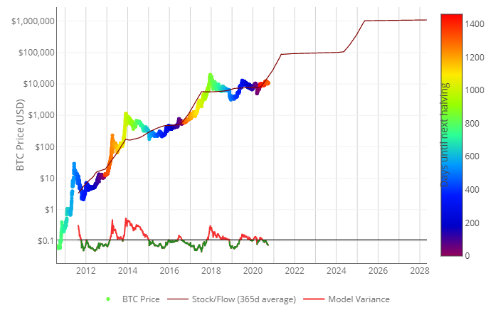

Figure 2. The chart Bitcoin prices over the year and S2F model *(source: Lookintobitcoin.com)*

**Why is the model is a bad idea for Bitcoin**

1. Theory was based on assumption:

From a theoretical point of view, the model is based on the rather strong assertion that the USD market capitalization of a monetary good (e.g. gold and silver) is derived directly from their rate of new supply. No evidence or research is provided to support this idea, other than the singular data points selected to chart gold and silver’s market capitalization against bitcoin’s trajectory.

1. Emergence of new coins:

The same way Bitcoin is thriving, a lot of newly emerging coins are also thriving, they also pose a competition for the most ‘*bullish’*. The model didn’t factor in the existence of other coins which will also gain popularity in the next few years, which in turn affects the prediction.

1. The model defies Physical Laws:

The model predicted exponential growths up till infinity and no single decline in value makes the model quite not feasible and very unrealistic. The model also assumes a steady exponential increase in the demand for bitcoin.

1. Putting into perspective, Gold’s S2F model, the Stock-to-flow ratio doesn’t drive the price of gold, so hypothetically the S2F ratio of bitcoin won’t necessarily influence the price of bitcoin which will in turn cause a deviation from the prediction of the model.
2. Anonymity of traders:

The fact that the bitcoin transactions are usually untraceable can be a factor that will reduce the popularity index of using it as a means of transaction, inadvertently reducing the market cap and value. The lower the demand for a commodity, the lower the price of the commodity.

According the S2F model, it predicted that after the next halving (in May 2020) the market cap of Bitcoin was going to increase up-to $1,000,000,000,000 (One trillion). As at September 2020, the market cap totals at ~ $200 billion, barely a 20% of the predicted value.

These along with other reasons make the Stock-to-Flow model a bad idea for Bitcoin.